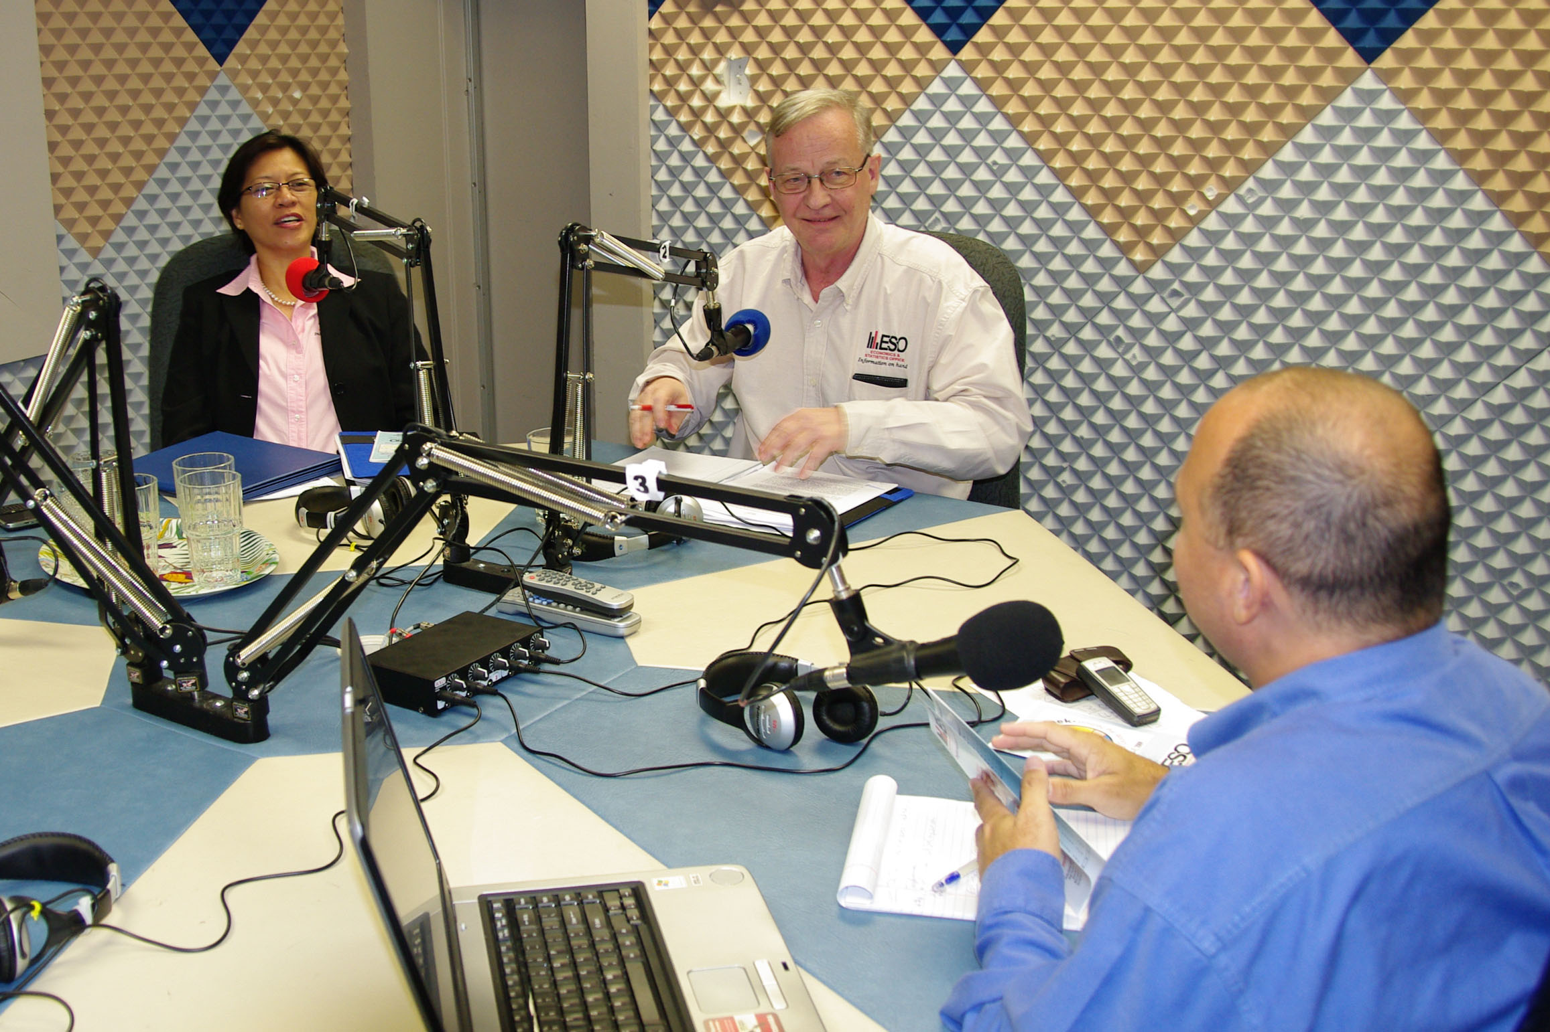
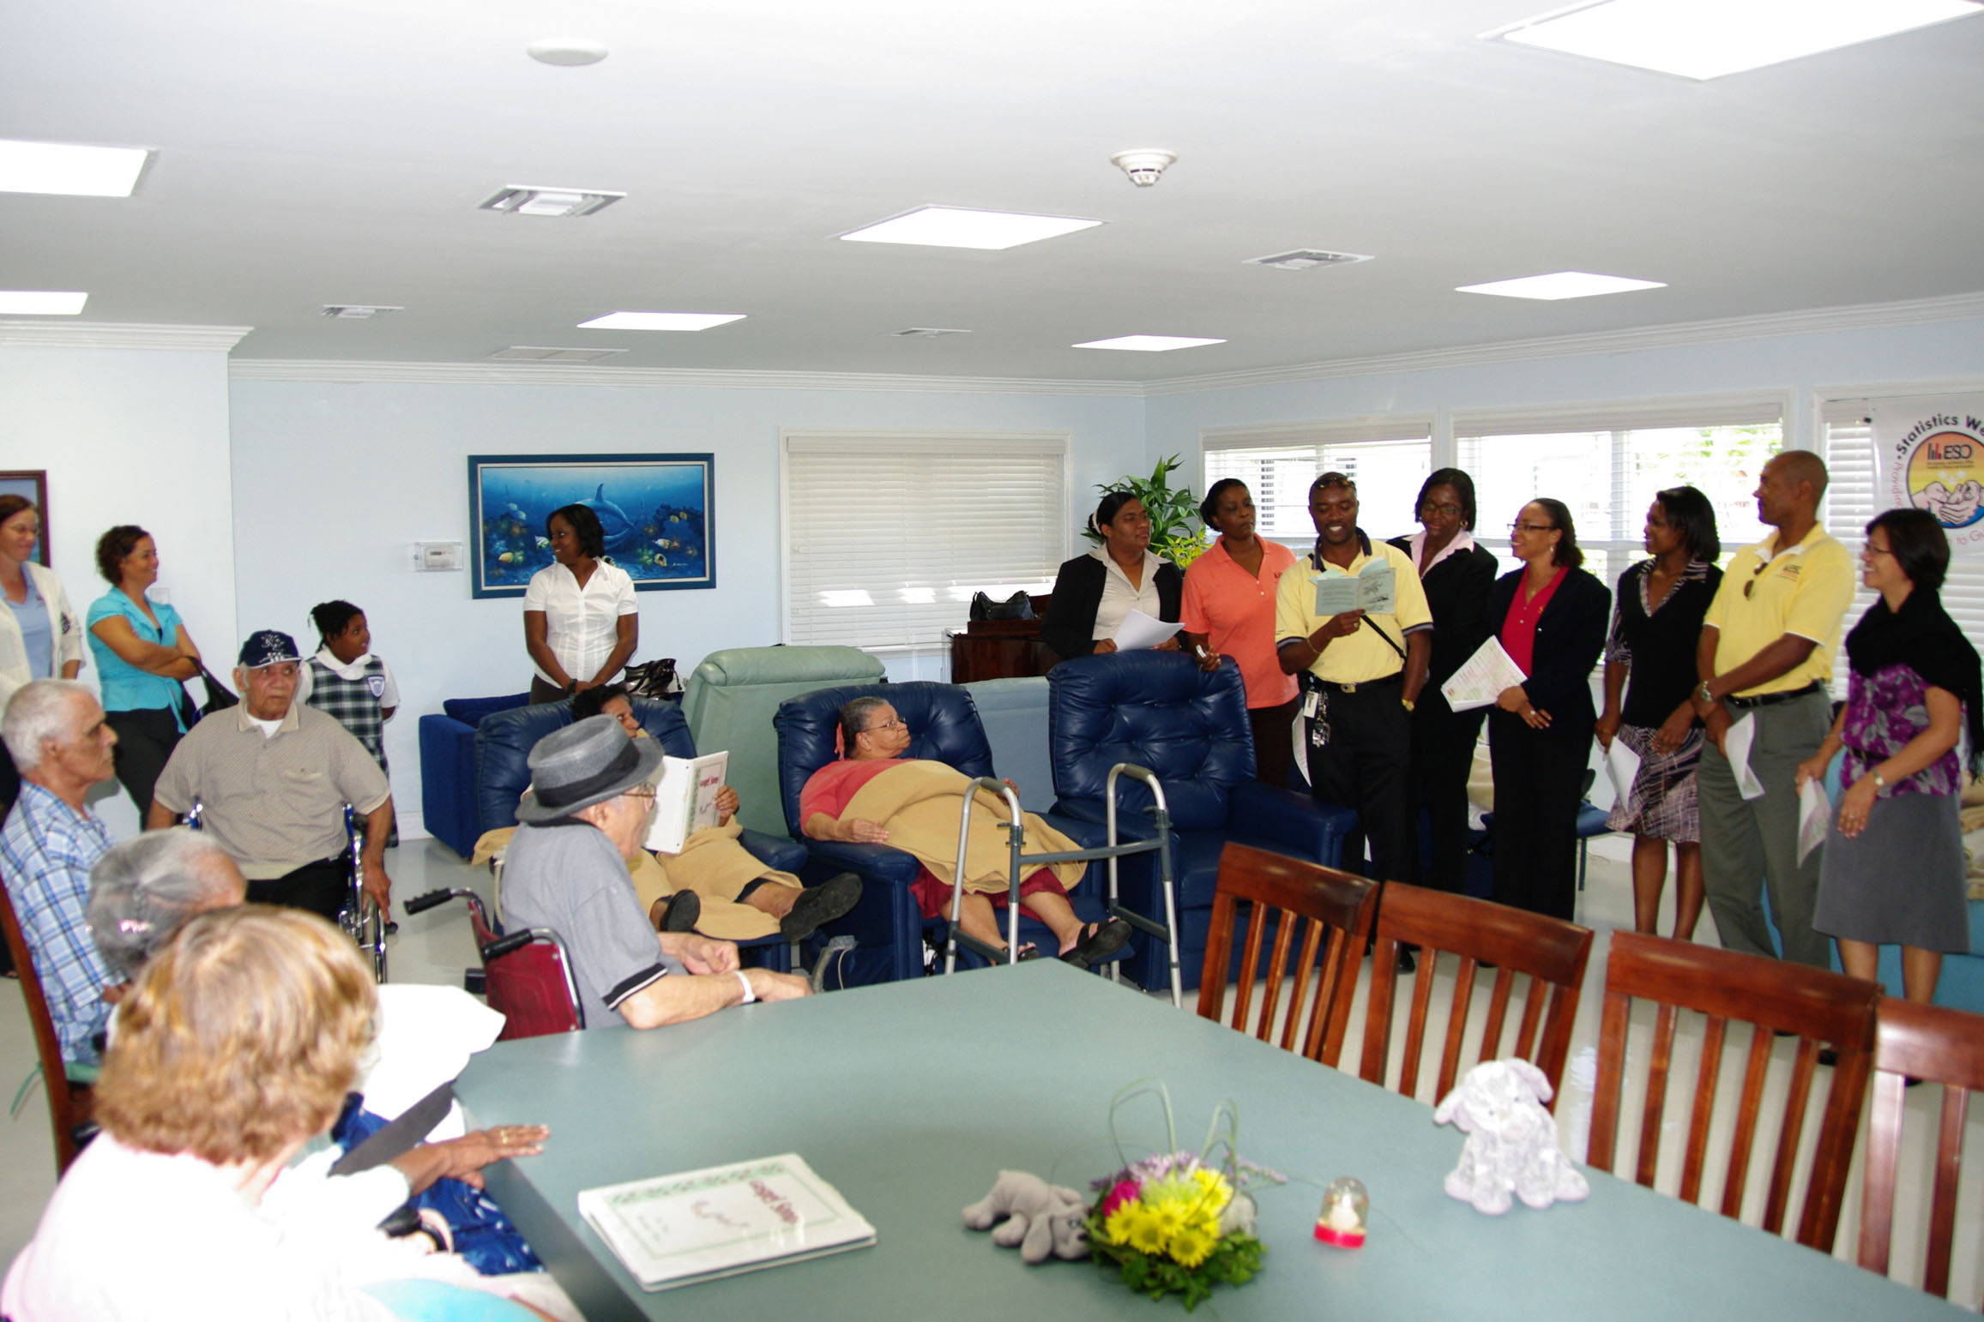

Radio Cayman Broadcast Visit to Pines Retirement Home
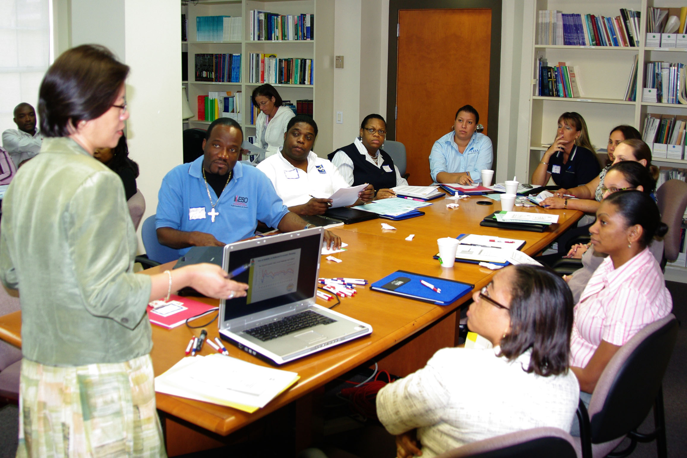
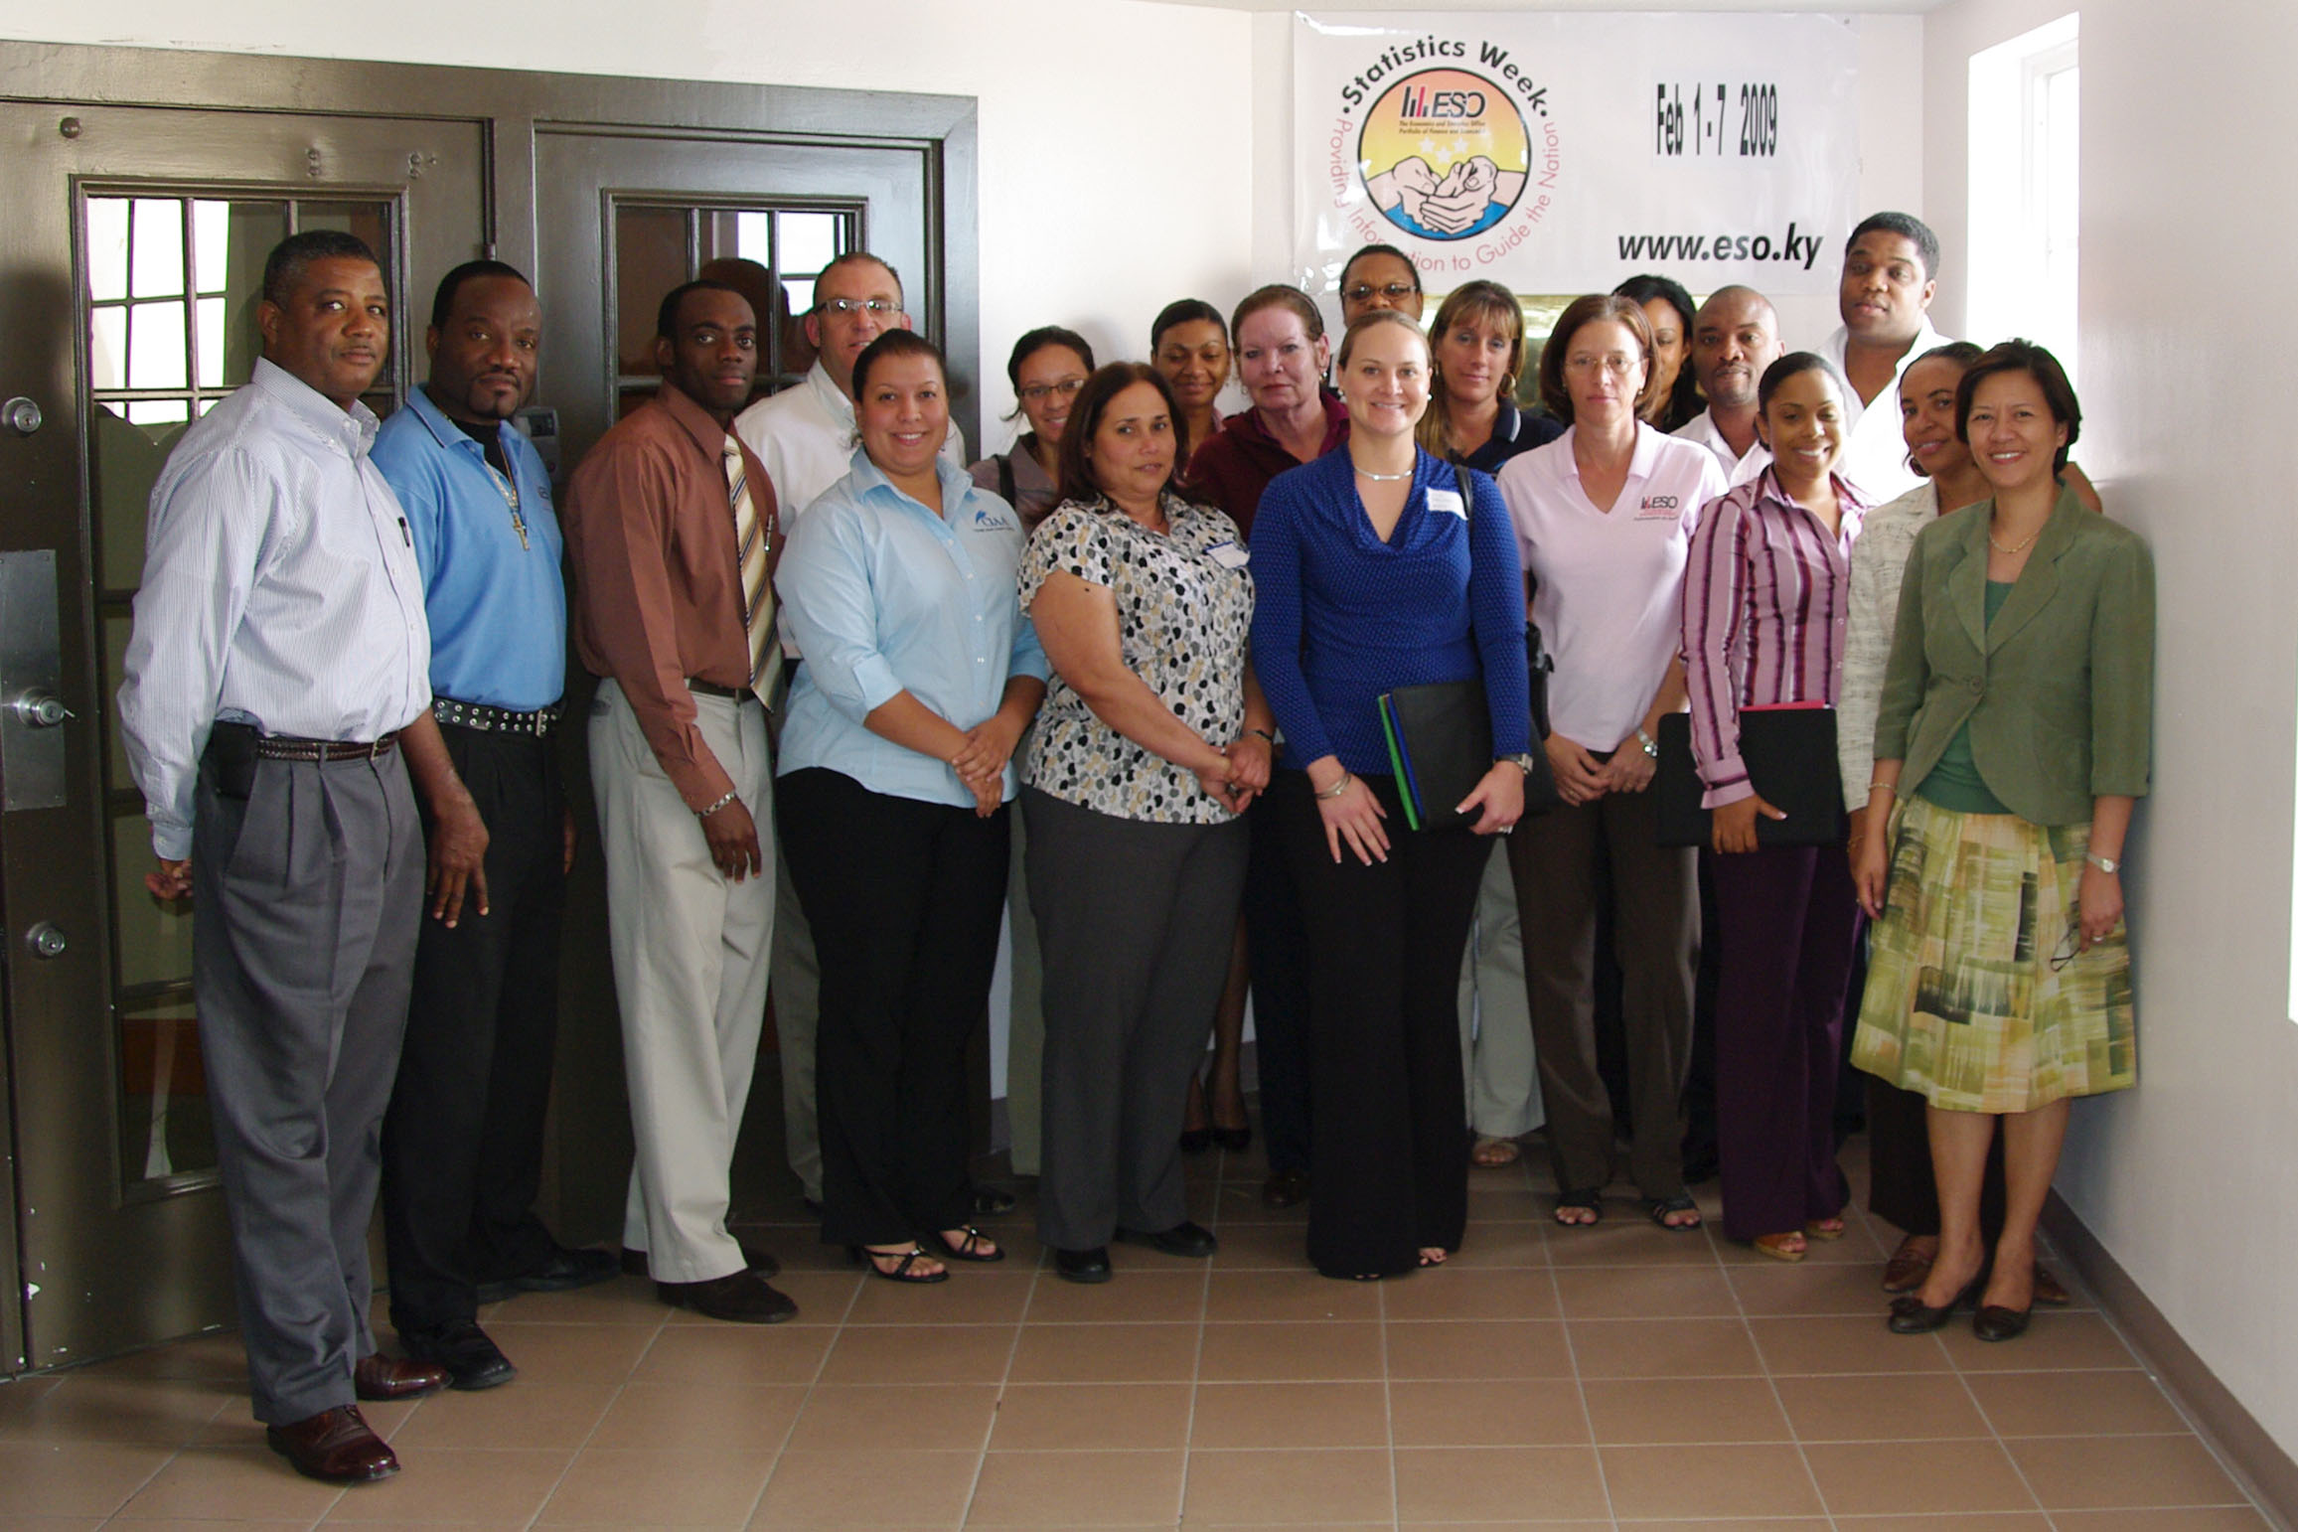

Basic Statistics Workshop Participants of Statistics Workshop
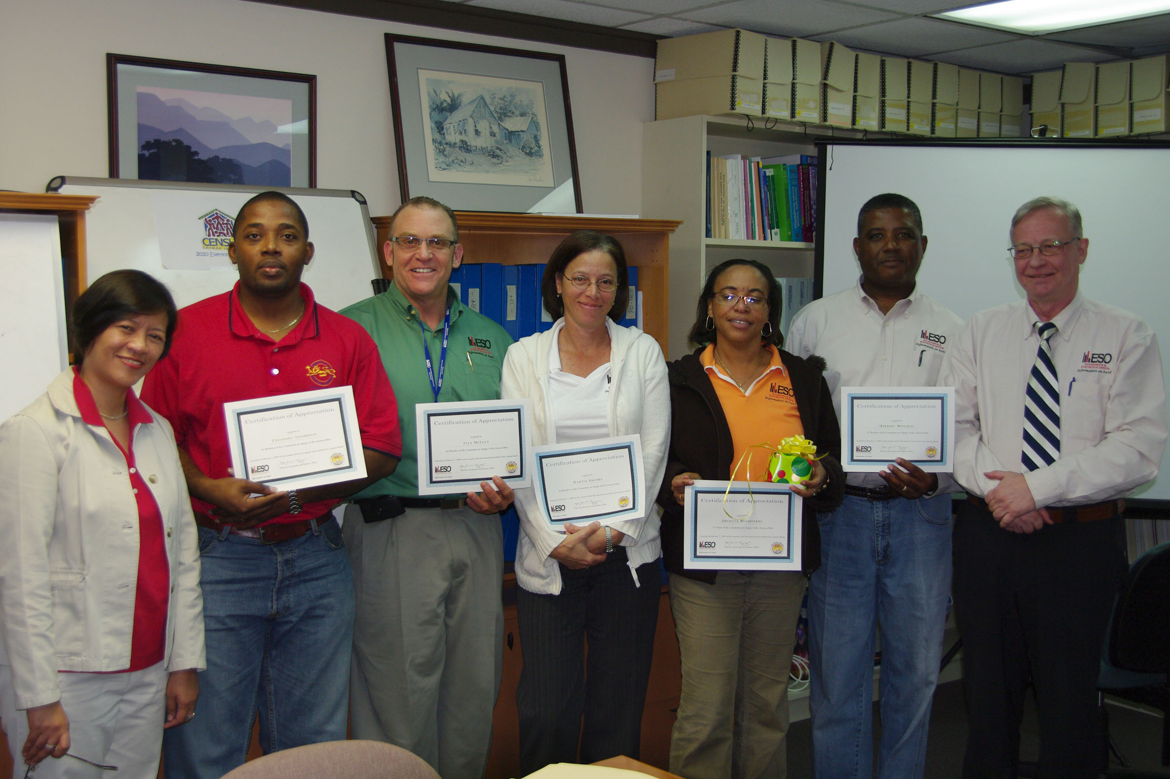
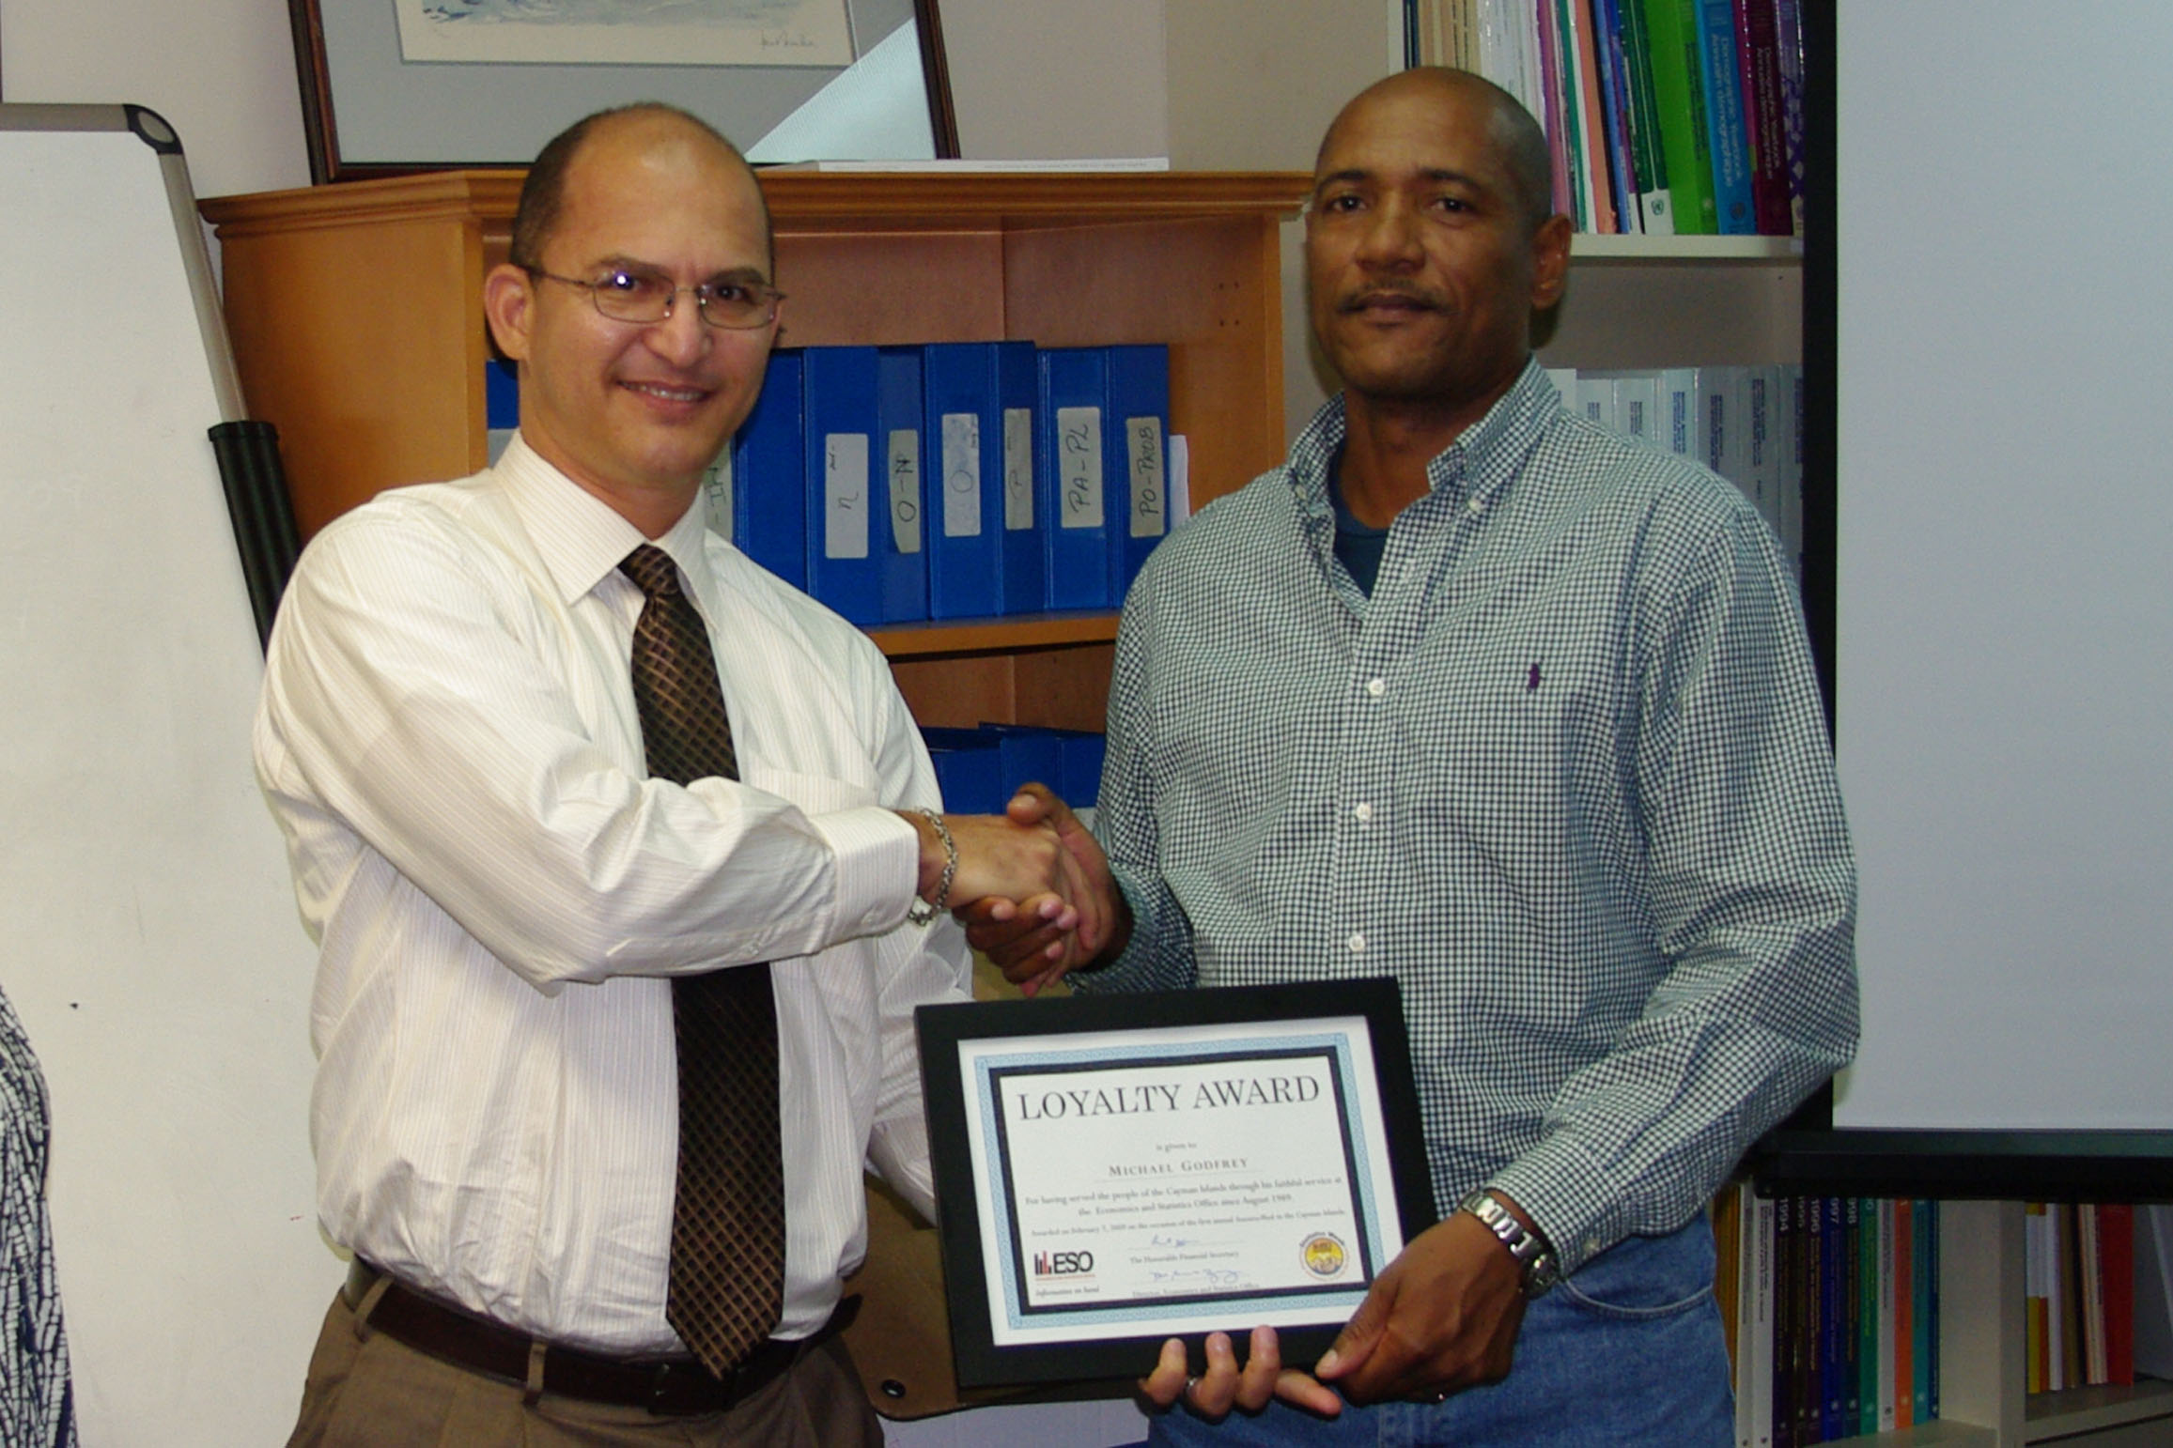

Awards Presentation
Financial Secretary Hon. Kenneth Jefferson presenting award to
Mr. Michael Godfrey for
Outstanding and Long Service
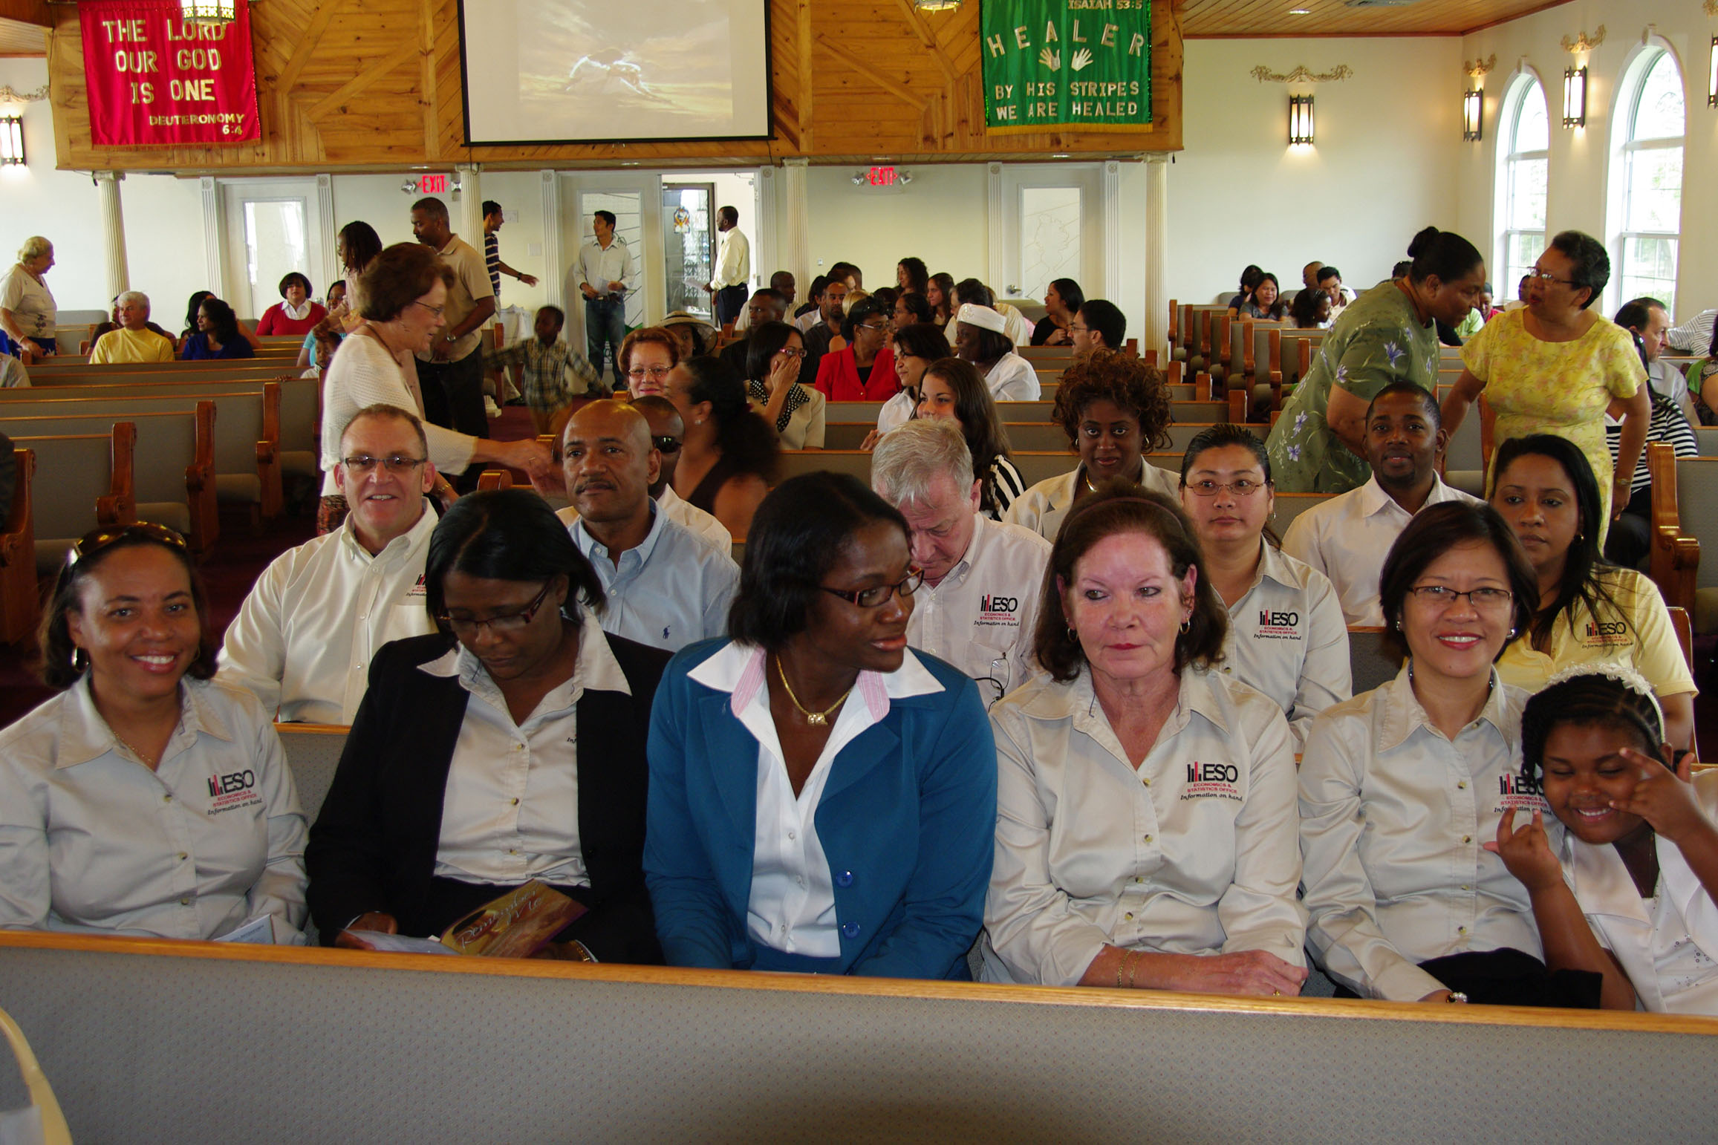
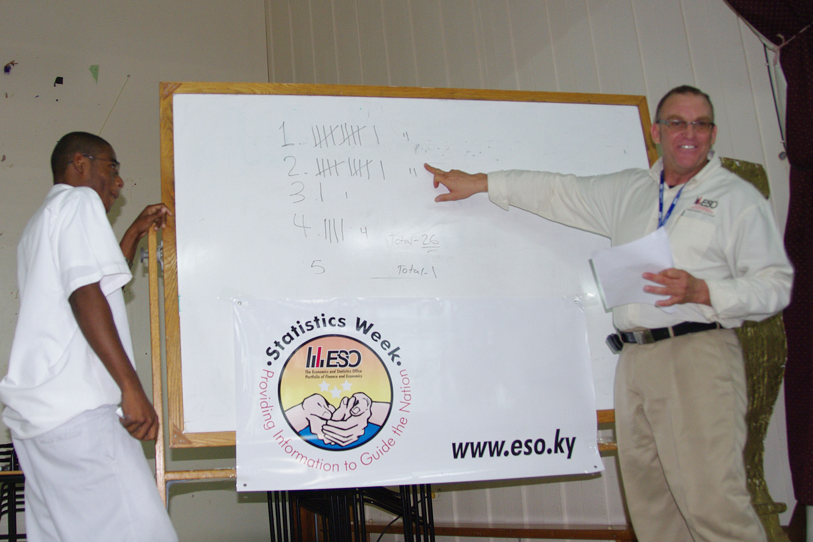

Church Service at the Presentation to John Gray Students
Church of God Walkers Road
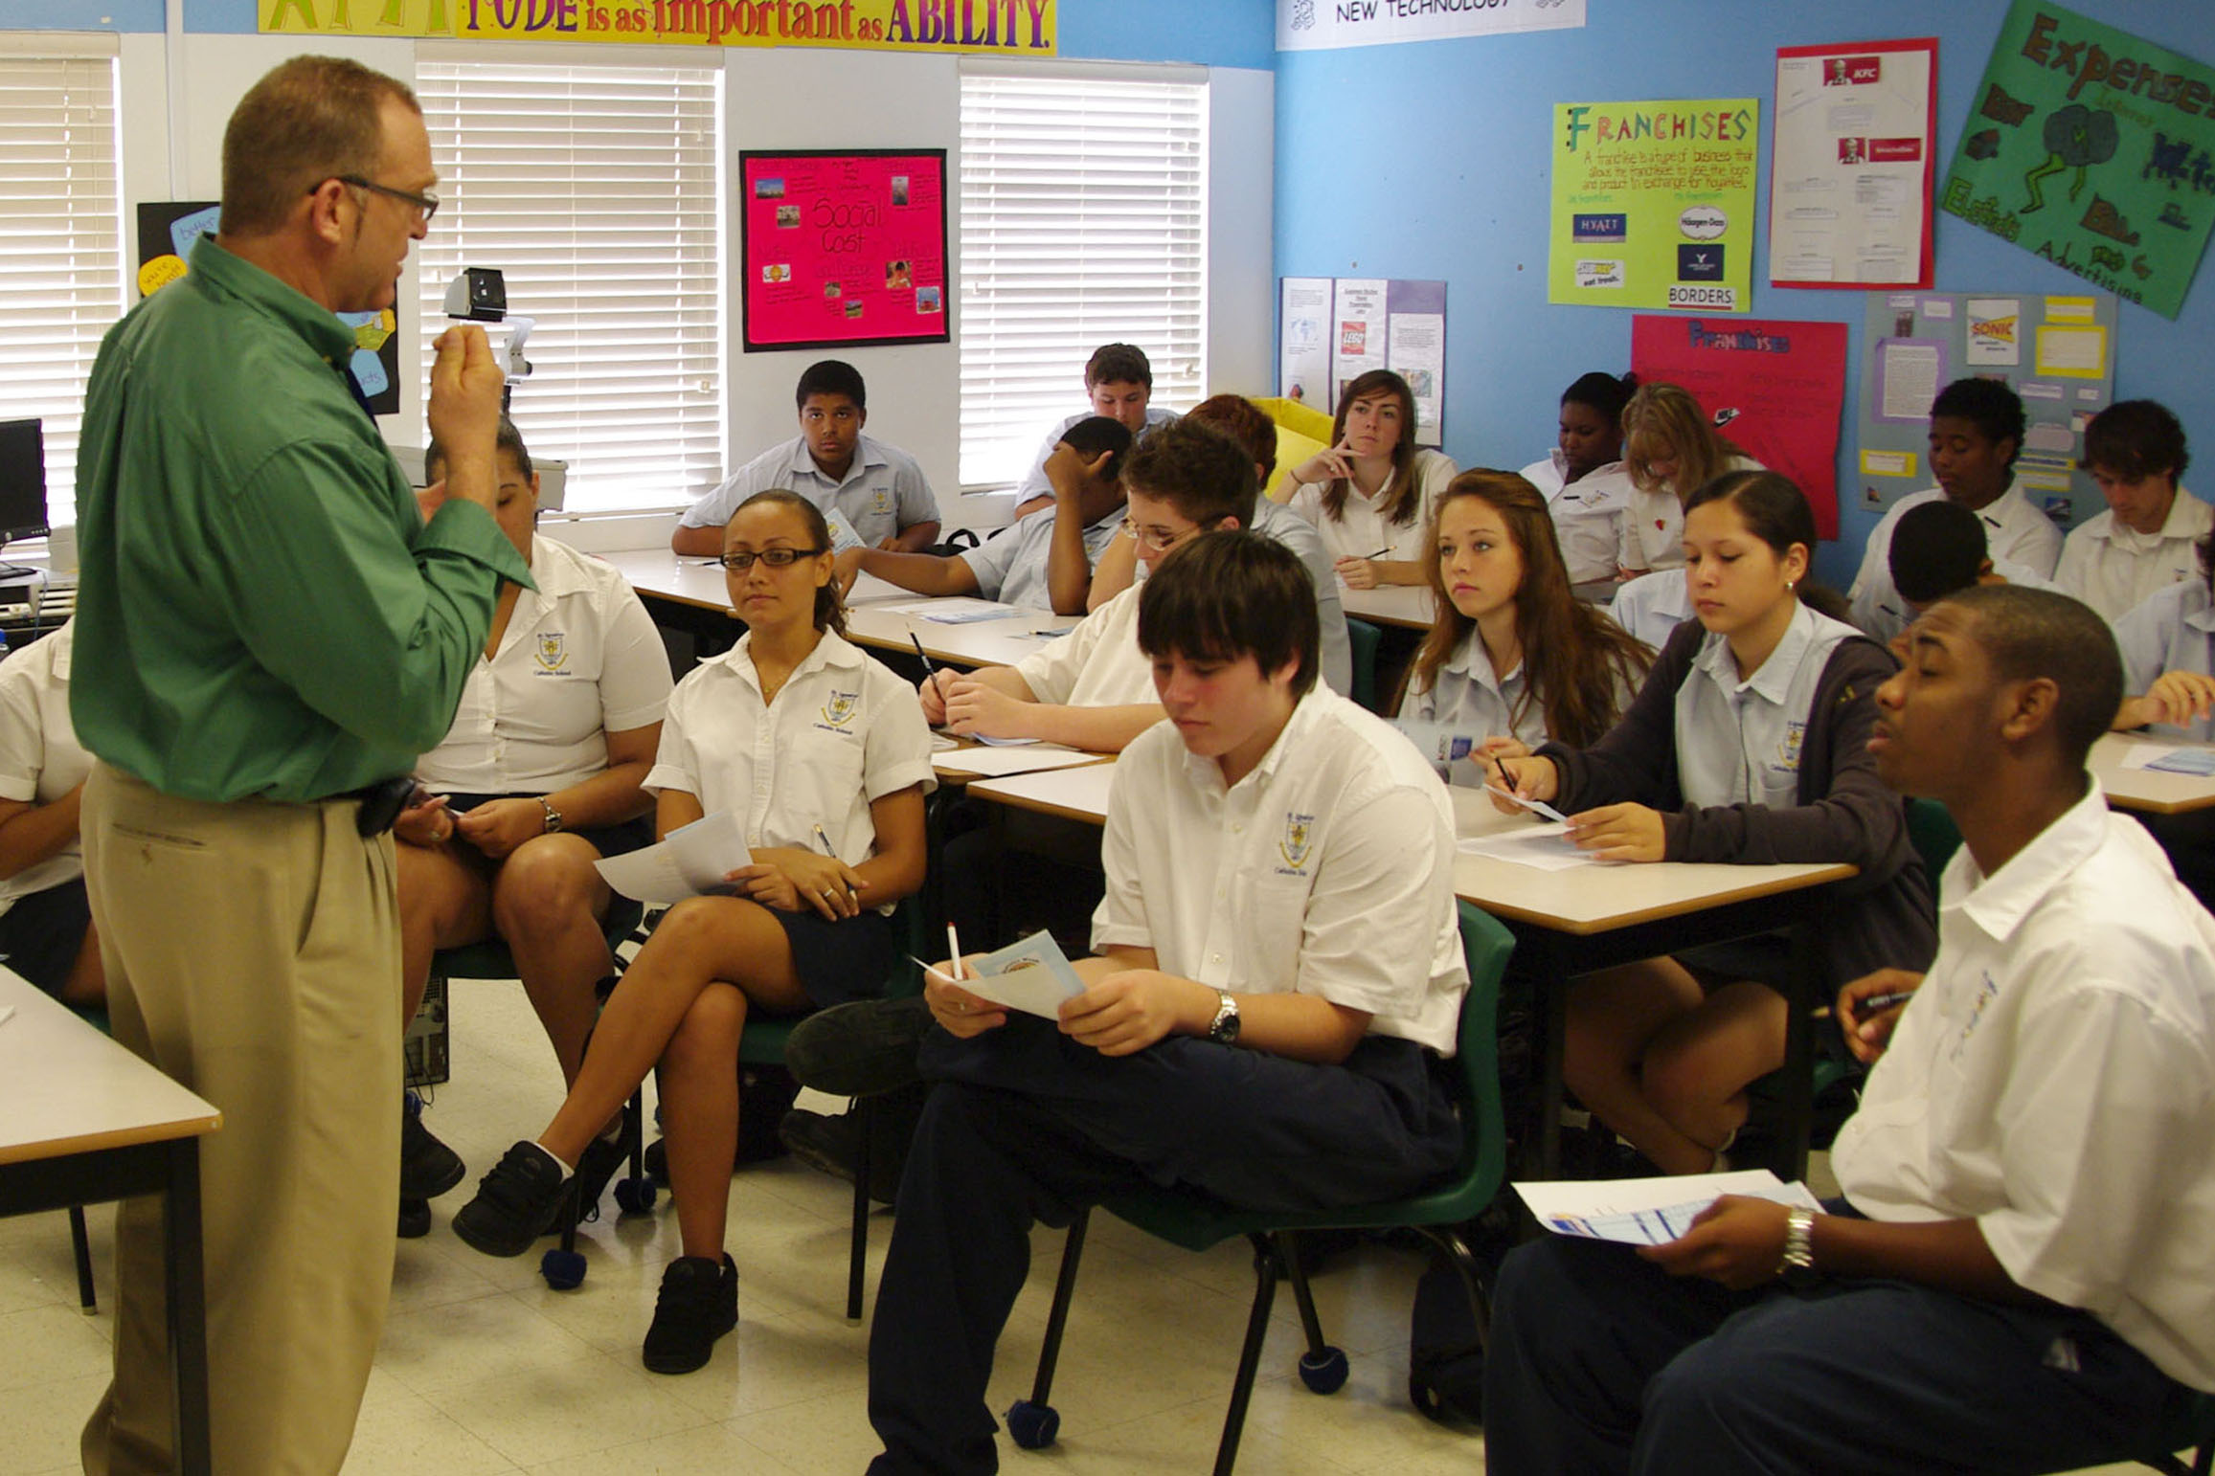
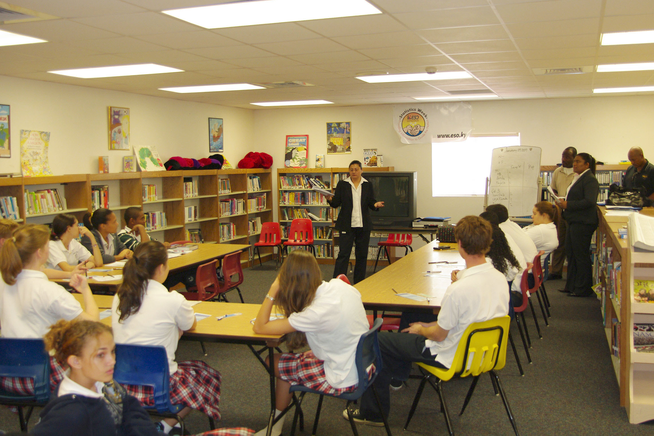

Presentation to St. Ignatius High School
Presentation to Triple C High School
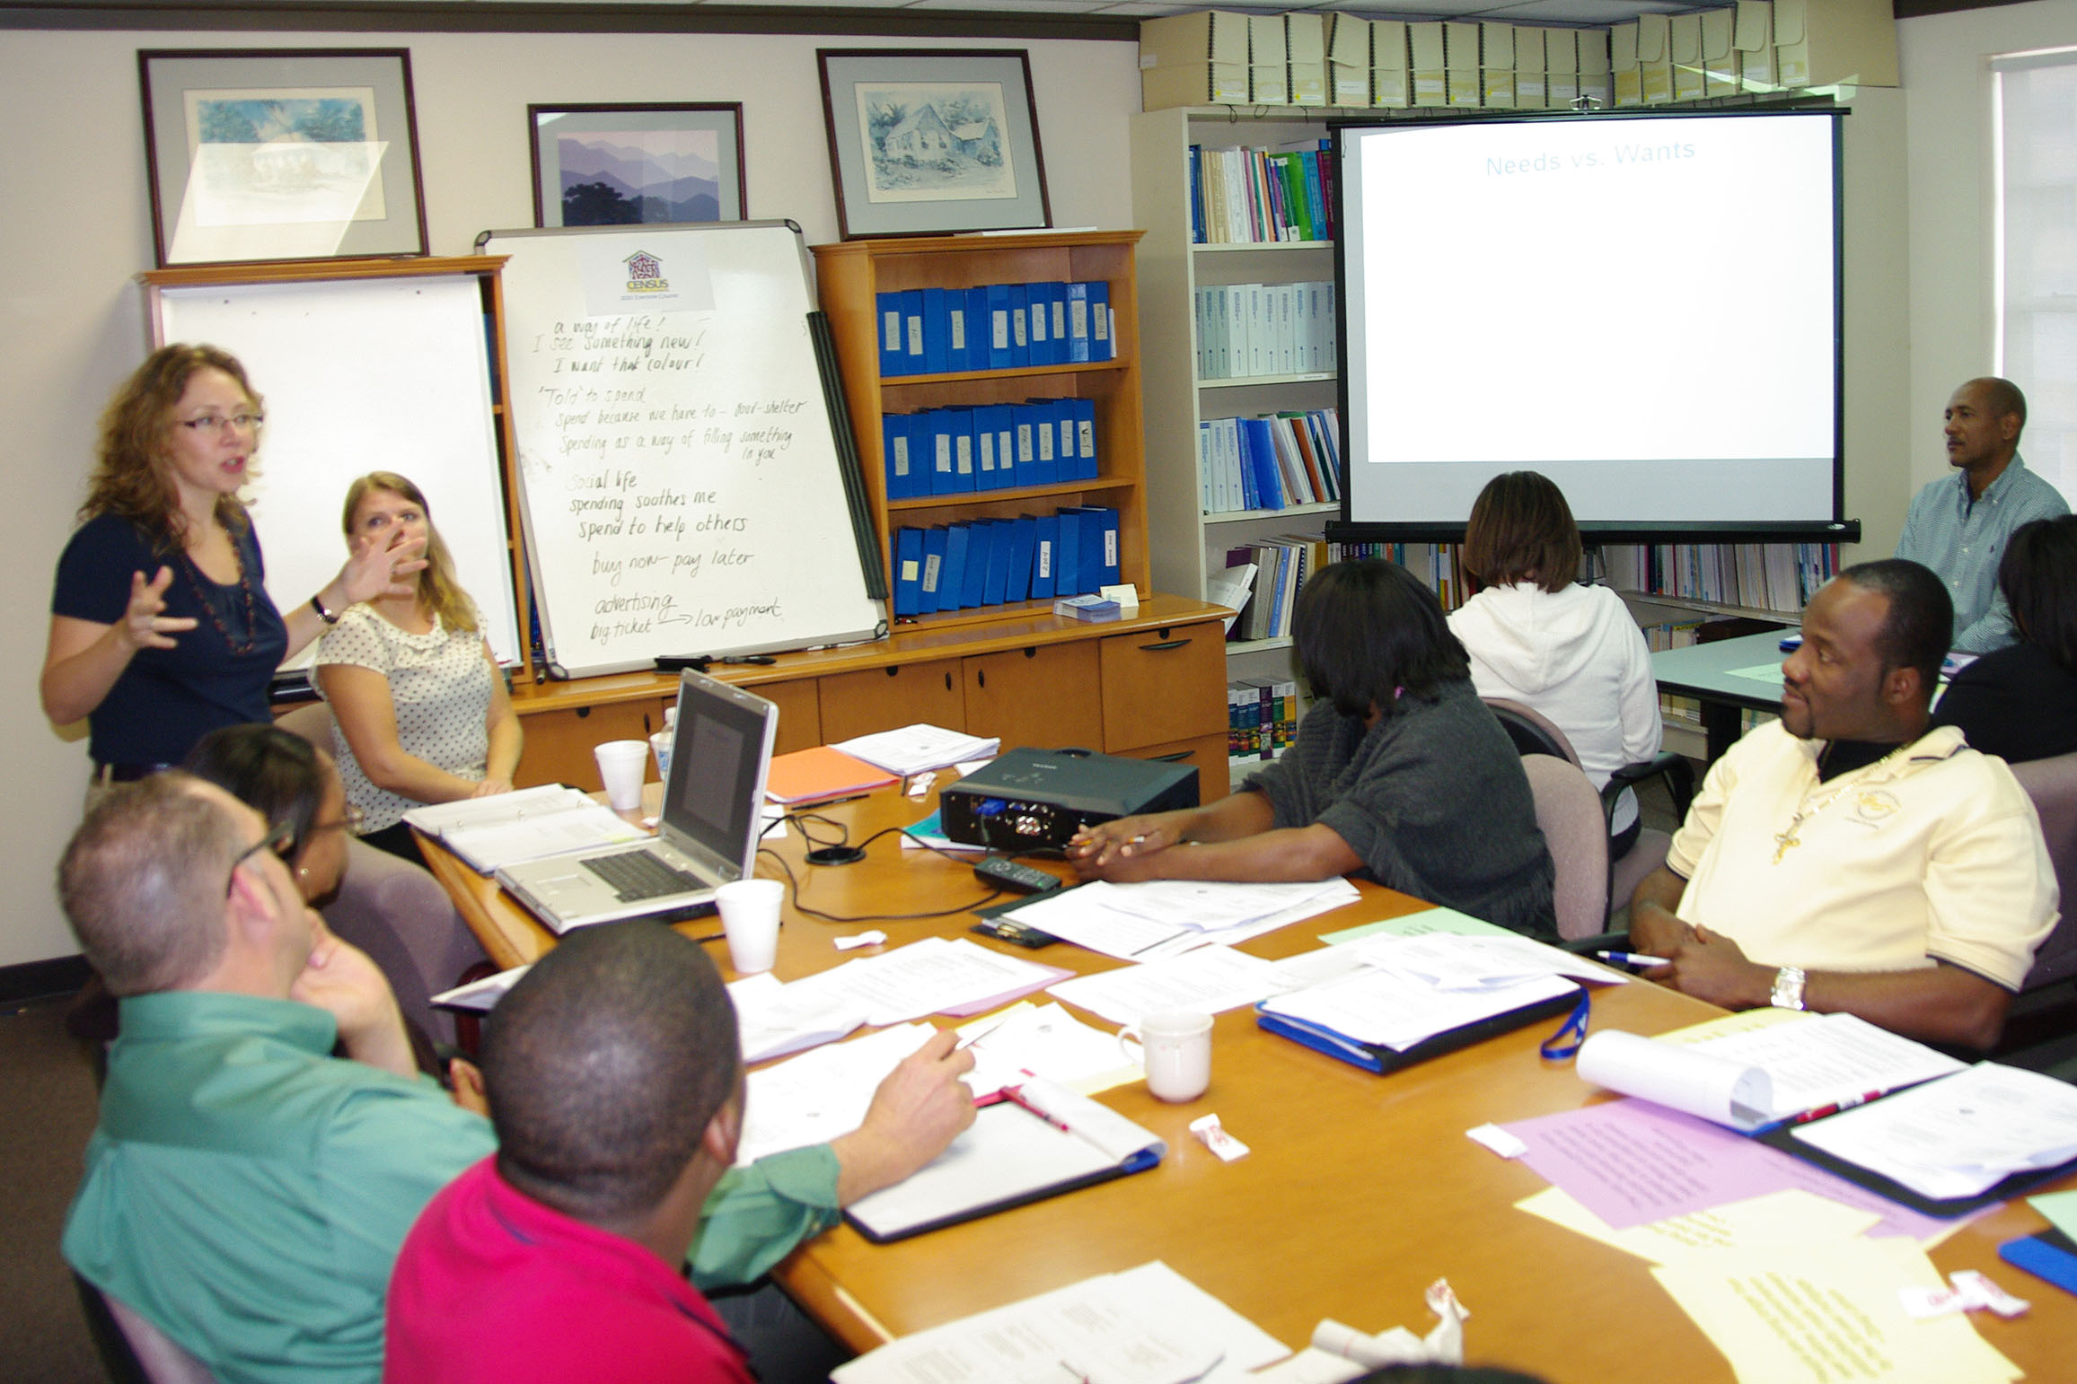

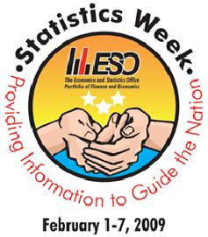

Statistics Week Program
Staff Development Workshop
Presented by EAP

